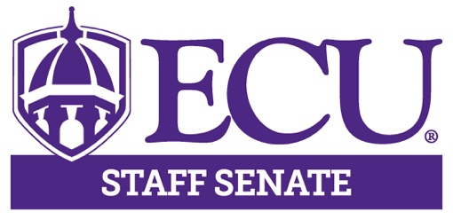
East Carolina University

Staff Senate Meeting

October 10th, 2019, 3-5pm

ECHI Auditorium

AGENDA

3:00 – 3:05 | Open Meeting – Roll Call | Karen Eastwood
3:05 – 3:10 p.m. | Approval of Minutes  - August  - September | Karen Eastwood
3:10-3:20 | Executive Committee Comments  - Chair – Michelle Bone  - Chair-Elect- Todd Inman  - Vice Chair- Debbie Pettaway  - Treasurer- Robin Mayo  - Secretary- Karen Eastwood | Exec Committee
3:20 – 3:40 p.m. | Committee Reports  - By-Laws  - Communications & Marketing  - Diversity  - Human Resources  - Membership  - Leadership & Professional Development  - Recognition & Rewards  - Scholarship | Committee Chairs
3:40– 4:30 p.m. | Leadership & Professional Development Series | Allen Dennis  Christy Carraway
4:30-5:00 p.m. | Round table discussion | All Senators
5:00 p.m. | Adjournment | Michelle Bone
Upcoming Meeting Dates

Staff Senate – November 14, 2019 3-5 p.m. Main Student Center room 249

