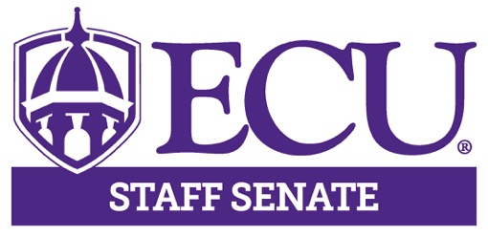
East Carolina University

Staff Senate Meeting

December 12th, 2019, 3-5pm

Main Campus Student Center- Room 249

AGENDA

3:00 – 3:05 | Open Meeting – Roll Call | Karen Eastwood
3:05 – 3:10 p.m. | Approval of Minutes  - November | Karen Eastwood
3:15- 3:30 p.m. | Staff Senate Photo  Committee Photos | All Staff Senate
3:30-5:00 p.m. | Holiday Social and Team Development | Michelle Bone  Todd Inman
5:00 p.m. | Adjournment | Michelle Bone
Upcoming Meeting Dates

Staff Senate – January 9th, 2019 3-5 p.m. Main Student Center room 249

