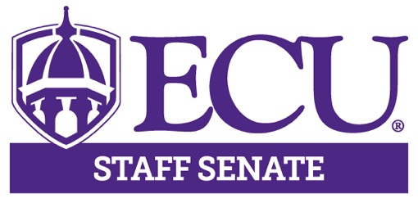

AGENDA

August 12, 2021

3:00 – 5:00pm

Teams Meeting

3:00pm Call to Order Hector Molina

3:00 – 3:30pm University Update Dr. Philip Rogers
Chancellor

3:30 – 3:50pm ERG Leaders Intro Toya Jacobs
American Indian Aleshia Hunt
Chinese Association Guili Zhang
LGBTQA Aaron Lucier
OBS Renita Harley

3:50 – 4:05pm University Ombuds John Howard

4:05 – 4:20pm CRW Jenny Gregory

4:20 – 4:25pm Approval of Minutes Kristin Wooten

4:25 – 4:35pm Executive Committee Hector Molina
Comments Aisha Powell
Lisa Ormond
Patrick Mitchell
Kristin Wooten
Logan Harrison

4:35 – 4:50pm Committee Reports Committee Chairs

4:50 – 5:00pm Open Discussion

5:00pm Adjourn Meeting Hector Molina

Next Meeting

August 12, 2021

3:00 – 5:00pm

Teams Meeting

