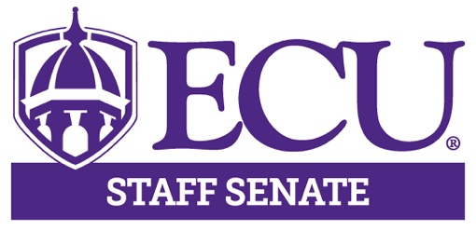

AGENDA

December 9, 2021

3:00 – 5:00pm

Teams

3:00pm Call to Order Hector Molina

3:00 – 3:25pm University Update Chancellor Rogers

3:25 – 3:45pm University Studies Dr. Amy Shannon

3:45 – 4:05pm Wellness Initiative Christy Carraway

4:05 – 4:10pm Approval of Minutes Kristin Wooten

4:10 – 4:20pm Executive Committee Hector Molina
Comments Aisha Powell
Lisa Ormond
Kristin Wooten
Olivia Cottrell

4:20 – 4:30pm Committee Reports Committee Chairs

Next Meeting

January 13, 2021

3:00 – 5:00pm

Teams

4:30 – 4:50pm Breakout Session Senators

4:50 – 5:00pm Open Discussion

5:00pm Adjourn Meeting Hector Molina

