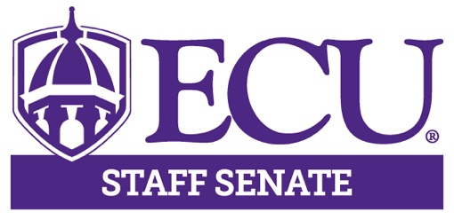

AGENDA

July 8, 2021

3:00 – 5:00pm

Teams Meeting

3:00pm Call to Order Hector Molina

3:00 – 3:30pm University Update Dr. Virginia Hardy
VC Student Affairs

3:30 – 3:50pm Remote Regulation & Fall Jeff Dozier
2021 Planning Update

3:50 – 4:00pm Ad Hoc Committee Erica Hoyt
Update

4:00 – 4:05pm Approval of Minutes Kristin Wooten

4:05 – 4:20pm Executive Committee Hector Molina
Comments Aisha Powell
Lisa Ormond
Patrick Mitchell
Kristin Wooten
Logan Harrison

4:20 – 4:45pm Committee Reports

4:45 – 5:00pm Open Discussion

5:00pm Adjourn Meeting Hector Molina

Next Meeting

August 12, 2021

3:00 – 5:00pm

Teams Meeting

