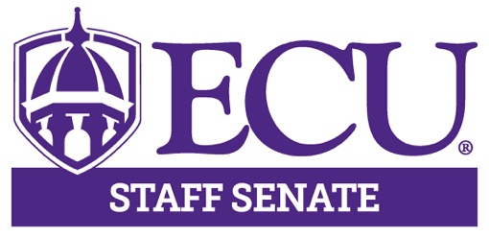

AGENDA

June 10, 2021

3:00 – 5:00pm

Teams Meeting

3:00pm Call to Order Hector Molina

3:00 – 3:20pm Campus Update Stephanie Coleman
VC Administration
And Finance

3:20 – 3:40pm Fall 2021 Planning Update John Southworth

3:40 – 4:00pm Summer MELT Erica Hoyt
Ad Hoc Committee

4:00 – 4:05pm Approval of Minutes Kristin Wooten

4:05 – 4:30pm Executive Committee Hector Molina
Presentation Aisha Powell
Lisa Ormond
Patrick Mitchell
Kristin Wooten

4:30 – 5:00pm Committee Breakout Hector Molina
Sessions

5:00pm Adjourn Meeting Hector Molina

Next Meeting

July 8, 2021

3:00 – 5:00pm

Teams Meeting

