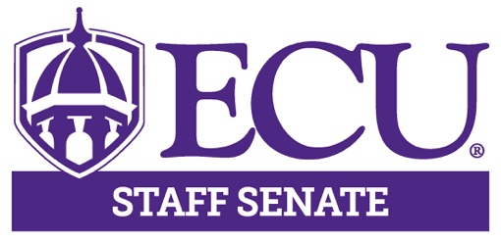

AGENDA

November 11, 2021

3:00 – 5:00pm

Teams

3:00pm Call to Order Hector Molina

3:05 – 3:10pm Approval of Minutes Kristin Wooten

3:10 – 3:30pm Executive Committee Hector Molina
Comments Aisha Powell
Lisa Ormond
Kristin Wooten
Olivia Cottrell

3:30 – 3:55pm Enrollment Stephanie Whaley

3:55 – 4:15pm Committee Reports Committee Chairs

Next Meeting

December 9, 2021

3:00 – 5:00pm

Teams

4:15 – 4:30pm Open Discussion

4:30pm Adjourn Meeting Hector Molina

